**SWISS Bank**

If you can afford us, you need us.

Foundation date: 25th Dec 2021

Patna-800025, Bihar

Anubhav Sharma

Consultant and Developer

Tata Consultancy Services Limited

Document

created by: Anubhav Sharma

last updated: 31-12-2021

status: INCOMPLETE

version: 0.0.1

|  |  |  |  |  |  |
| --- | --- | --- | --- | --- | --- |
| Serial Number | Version | Date | Summary of Update | Author | Approved By |
| 1 | 0.0.1 | 31-12-2021 | First version of doc in progress | Anubhav Sharma | N/A |
|  |  |  |  |  |  |
|  |  |  |  |  |  |
|  |  |  |  |  |  |
|  |  |  |  |  |  |
|  |  |  |  |  |  |
|  |  |  |  |  |  |

* Above to be maintained by latest first

Contents

1. Basic features
2. Components used
3. Architecture (application level)
4. Architecture (System level)

**Chapter 0. Preface and Acknowledgement**

This app is solely for education purpose. I have tried to include as many features as required in an actual banking application. Will keep updating the application. The only obstacle could be “boring”. While creating this doc, I am already bored enough.

Anyways, I would like to thanks Stack overflow, YouTube, Spring developers and numerous other web pages for their help in development and testing of the application throughout the period, and also my current employer TCS limited, which gave me enough time and experience to enable me to create this application and this doc and of course special thanks to all my students who patiently listened to my boring description of the coding I have done (though not having any interest or knowledge in this field).

As of now, this application is built solely on Spring Boot. I will try not to make it more complicated but additional technologies would need to be integrated as per requirement.

If you are reading this, you are either my next employer, a potential client (hoping that I have become a freelancer/entrepreneur by now), one of my students (in this case you don’t have a choice) or an equally boring person as me.

Now, let’s get started.

PS: This doc and application is not at all confidential or restricted or even remotely secured. If you find it somewhere, please feel free to create/update/delete as per your need. Also, the author/developer won’t be responsible in any way if in case you managed to blow up your system because of improper configurations or poor logic implementation inside the application. So, use at your own risk. But I have never purposefully tried to incorporate any kind of virus or malware into the application. If any such issue found, please contact me via [Anubhav Sharma](mailto:anubhav8804602148@gmail.com).

1. Basic features

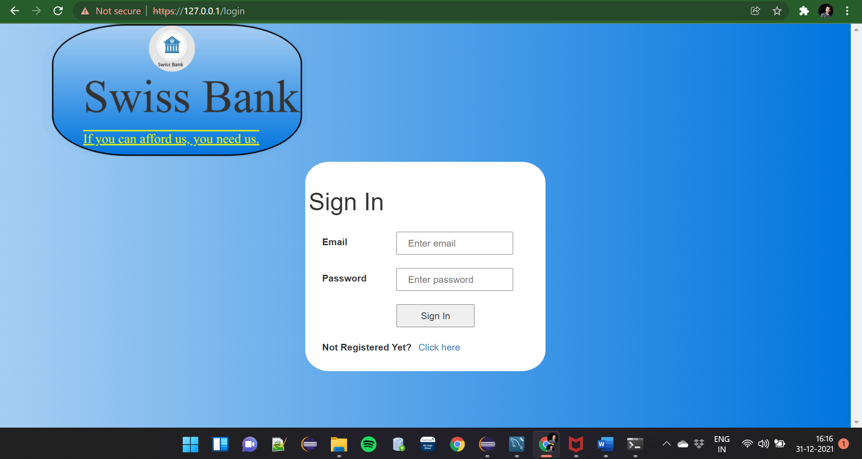

Fig 1.1

Fig 1.1 shows login page of the application. This is the entry point. Whichever page you try to access, all of it is secured. You will fall back to this point (except for register or error page). The user id is your email address and the password is what you chose while registering for the application. For now, no forgot password option is available. In case you need to update your password, please contact our application support team 😊.

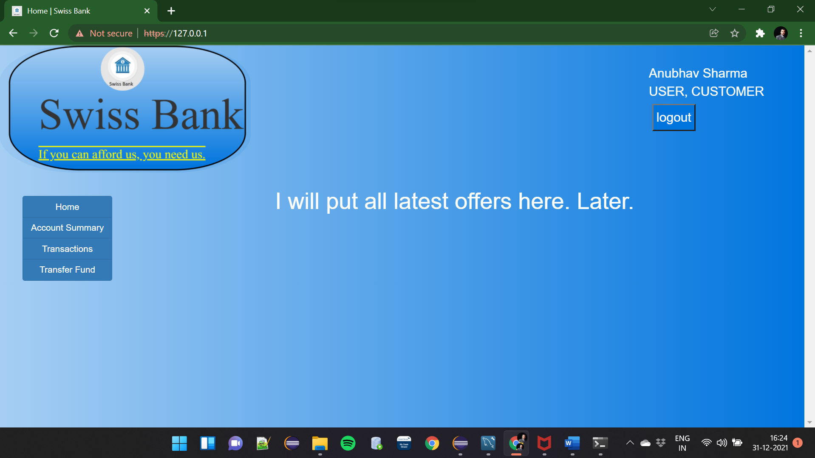

Fig 1.2

Fig 1.2 shows our home page. As you can see, I haven’t completed this part yet. This page is expected to show all extra facilities provided by my bank like fixed deposit, insurance. Top right corner shows your name and your designation. Top left is our logo (it was also there in login page). On the left-hand side, we have our navigation tab. Don’t click on home, it points to this page only. Let’s try other options. But hey, first things first, register.

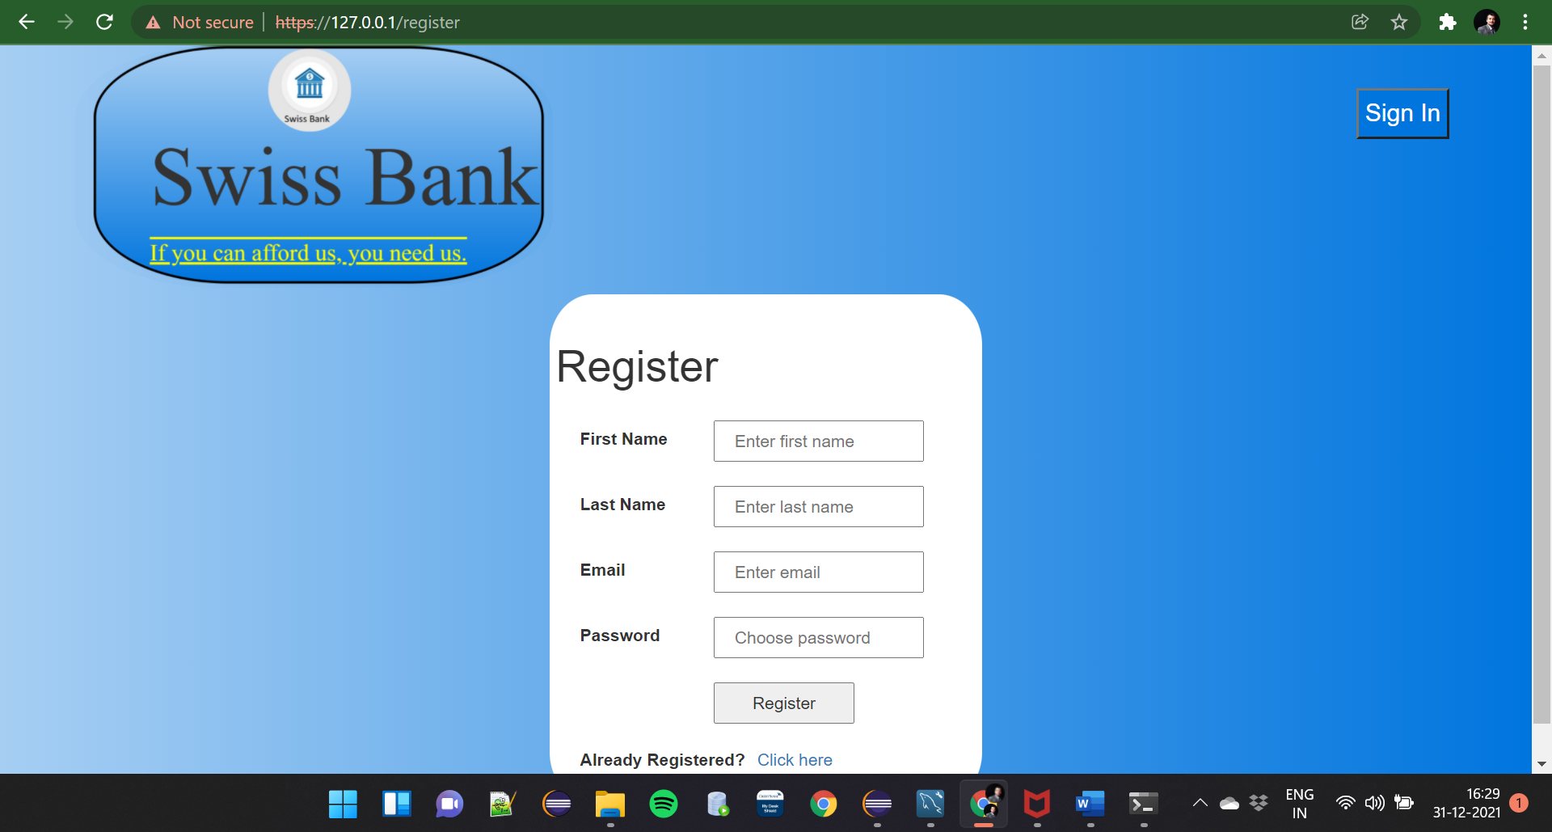

Fig 1.3

Fig 1.3 shows register page. Enter your first name, last name and email address and choose a strong password (Why?? 😐).

First name can only contain character and shouldn’t be more than 20 chars long, same is also true for last name. Email validation is taken care by basic html tag. Password should be at least 8 characters and must contain one uppercase, one lowercase and one special character.

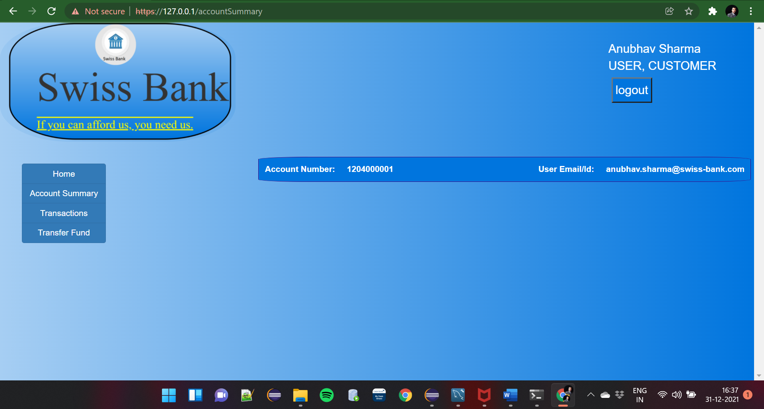

Fig 1.4

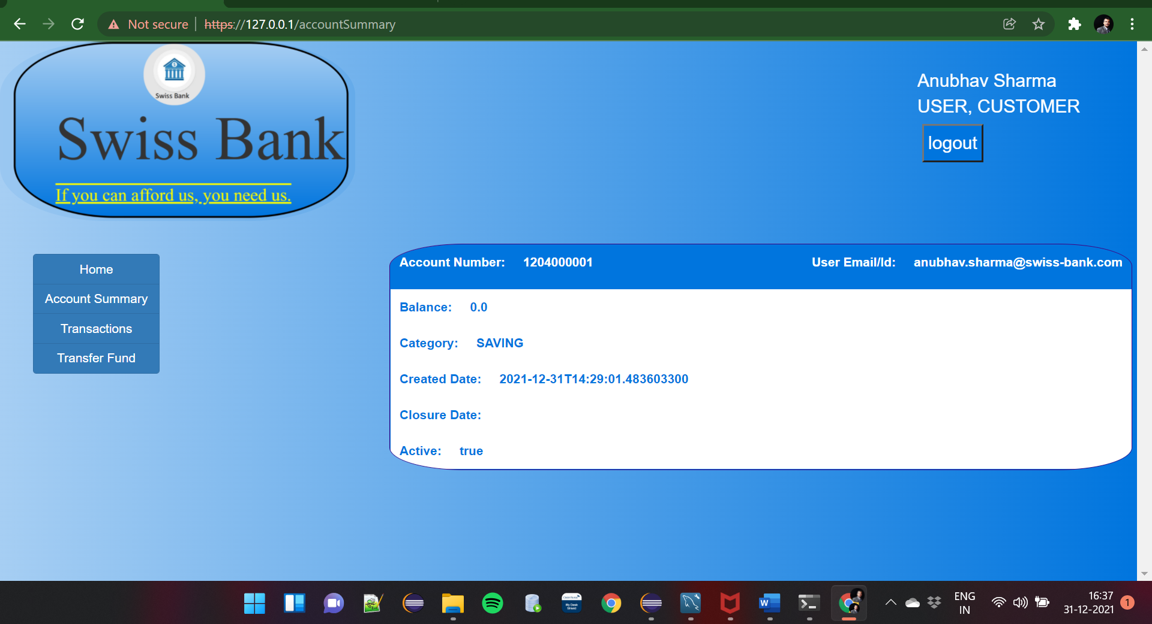

Fig 1.5

Fig 1.4 and 1.5 shows account summary page. They contain basic information like type of account, created date, closure date, status and balance. Not to mention account number and user id as their header. The body is only visible when you hover over their header. You con have multiple accounts, but not of same category. One account per user per category. How? Just go to create account page. Where??? [Create account](https://127.0.0.1/createNewAccount) You don’t see it in page? Ok. My mistake. Will add in later update. By the way if you don’t have any account, then the link is visible. Check Fig 1.6

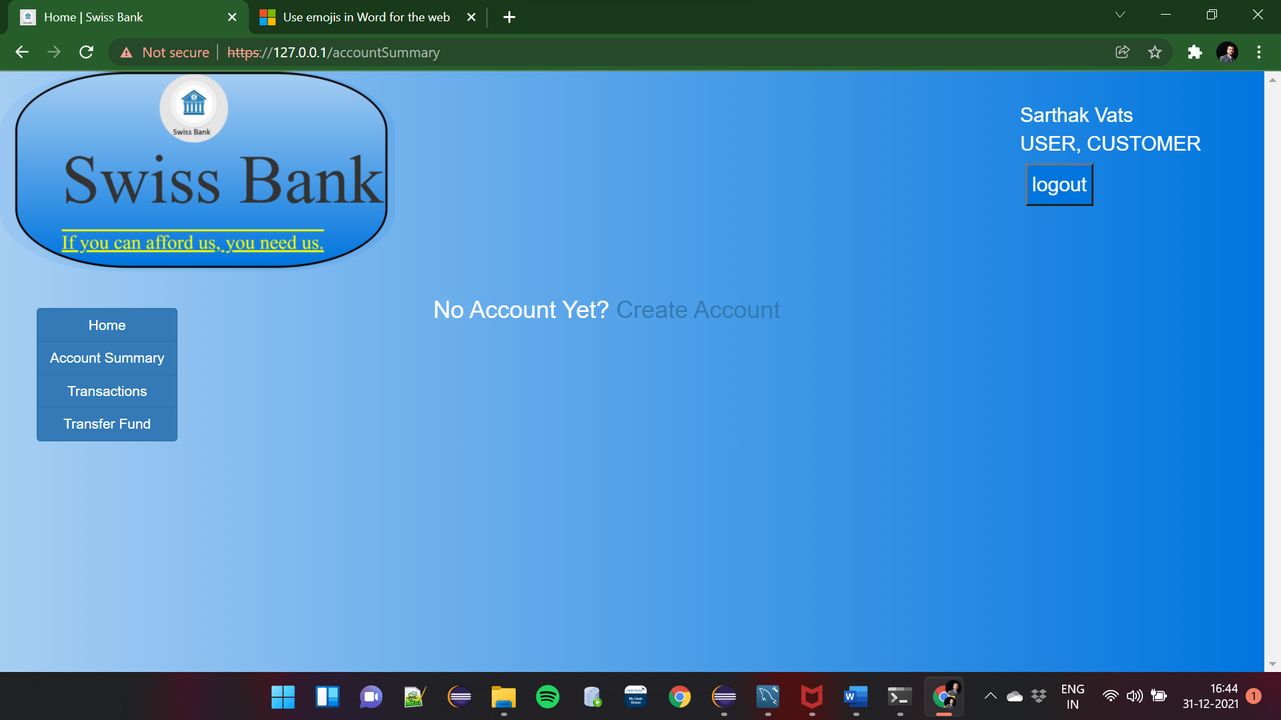

Fig 1.6

I just created a new user in order to show this. Check in the centre, you will see a link to create a new account. (All names apart from my own used within this document are imaginary and have no connection to any living or dead. Any such connection found is mere co-incidence).

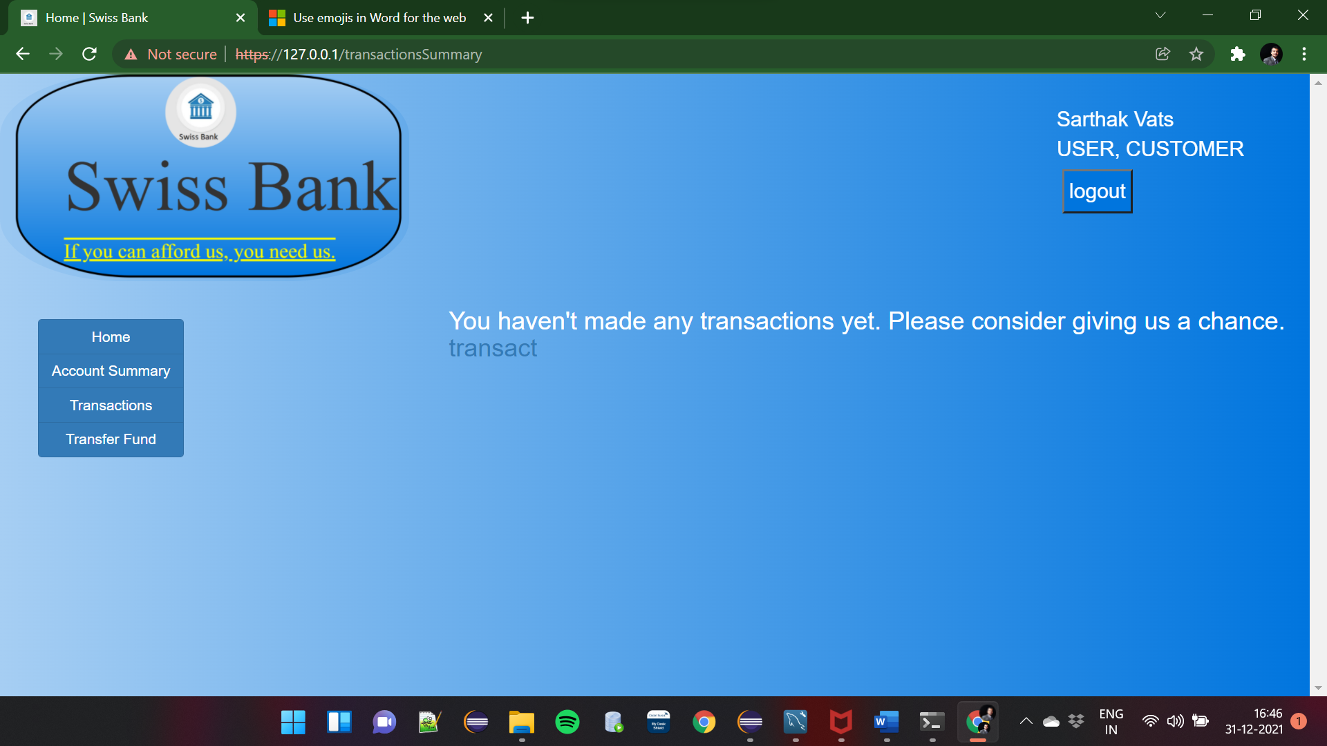

Fig 1.7